LINUX BASIC COMMANDS
PART-4

1)find: used to find files and directories and perform operation on them.

Find [path] -name [file_name]

find [path] -mtime -[days]
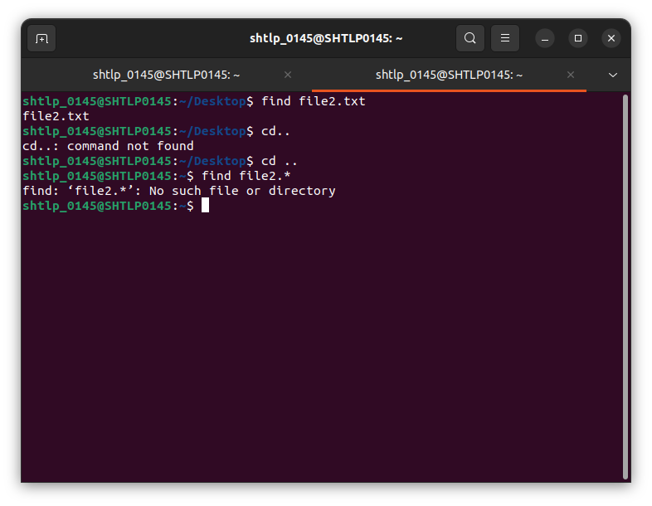
2)wc: count file’s word,line,character or byte count.

wc [file_name]

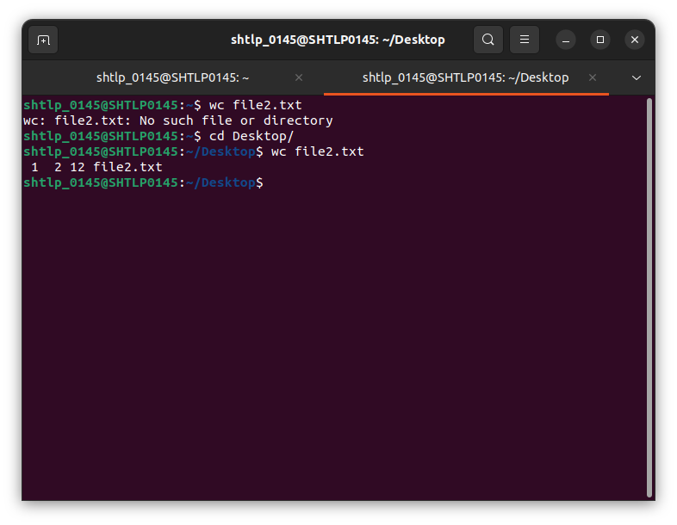
3) cal:calender command to see the calender of a specific month.

4)date:used to change the date and time of system

date -s [date] [time] :set system time and date

5)apt-get: tool for interacting with advanced package tool(APT).allows to search,install,manage,update and remove software.

6)ifconfig:used to configure kernal resident network interfaces.

7)tar: tape archive used to archive and extract archive files.It also used to create compressed and uncompressed archive files and maintain and modify them.

Tar [options][filename.tar][file_to_be_compressed]

tar -cf test.tar file1- : this will create tar file of file1
tar -xf test.tar file1 :this uncompress the tar file
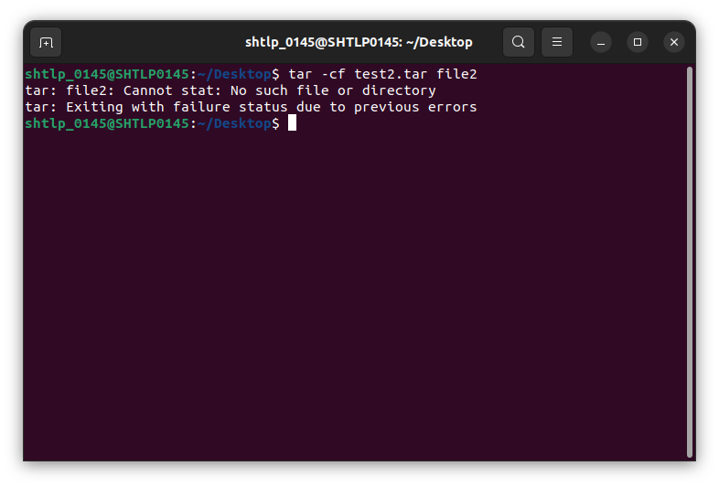
8)grep:search a file for particular pattern of characters and displays all the lines that contain that pattern.
Note: grep command is case sensitive by default.we can use -i to make it case insensitive
Grep [options] pattern [files]

-n flag is used to print the line number.
-v flag for invert match.
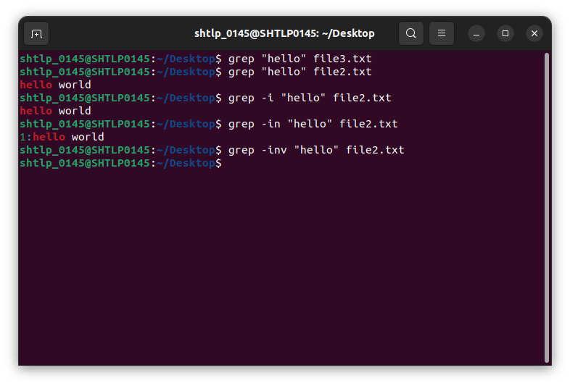

9)netstat:displays network related information such as network connections,routing tables etc.
(network statistics)

netstat -a: connection available on your system as well as shows status.
Netstat -a | less
netstat -at | less: shows tcp connections
netstat -au | less: shows udp connections
netstat -lt |less: shows listening tcp connectons

